Hi All,

As a reminder, the late arrival phenomenon has impacted both IrisView Alarms as well as the KPI Exports to external tools such as ALPT/ELPT.  To review, IrisView allows for additional IPI data records to be added to KPIs up to four hours after the 5-minute KPI interval has closed.  While this allows for greater accuracy (which is good), it creates problems for more time-sensitive event such as alarms (false alarm, KPI mismatches) or KPI export (KPI mismatches between ALPT/ELPT and IrisView).  Tek delivered a set of updated slides (attached) and NSS performed an updated analysis to compare ALPT/ELPT with IrisView (thanks Bob as well for the follow-up question).

Tek has taken several steps to improve the problem with late arrivals:

* Added a 30-minute delay to the trigger for ALPT/ELPT KPI exports to buffer against late arrivals on the night of 4/30.
* Found an issue with an NEC server source timing which was corrected 5/2

**An initial analysis following the added 30-minute delay to KPI export yielded positive results.  However, the analysis below indicates that problems still remain** (see screen captures and attached spreadsheets)

Comments - The analysis was performed on a KS/MO eNB to eliminate timezone as an issue for Daily KPIs as both ELPT and IPI use Central Timezone in the example below. The analysis used the \***vzwims**\* filter in IPI because I believe that this best replicates the KPI export but no other APN was found except for the expected *vzwims.mnc480.mcc311.gprs* APN.

Next Steps:

* NSS will continue to push Tek for a resolution
* As directed by the Core Team, NSS will look at chnaging the KPI export delay from 30 minutes to an hour to see if this improves the issue as a near-term solution for KPI Export (this will obviously not impact the sitaution regarding late arrivals and false alarms)
* In addition, Tek will be tasked to set-up a test KPI export in order to evaluate the health of late arrivals until a formal System Health KPI can be delivered.

Regards,

Nick

Daily Comparison – ELPT and IrisView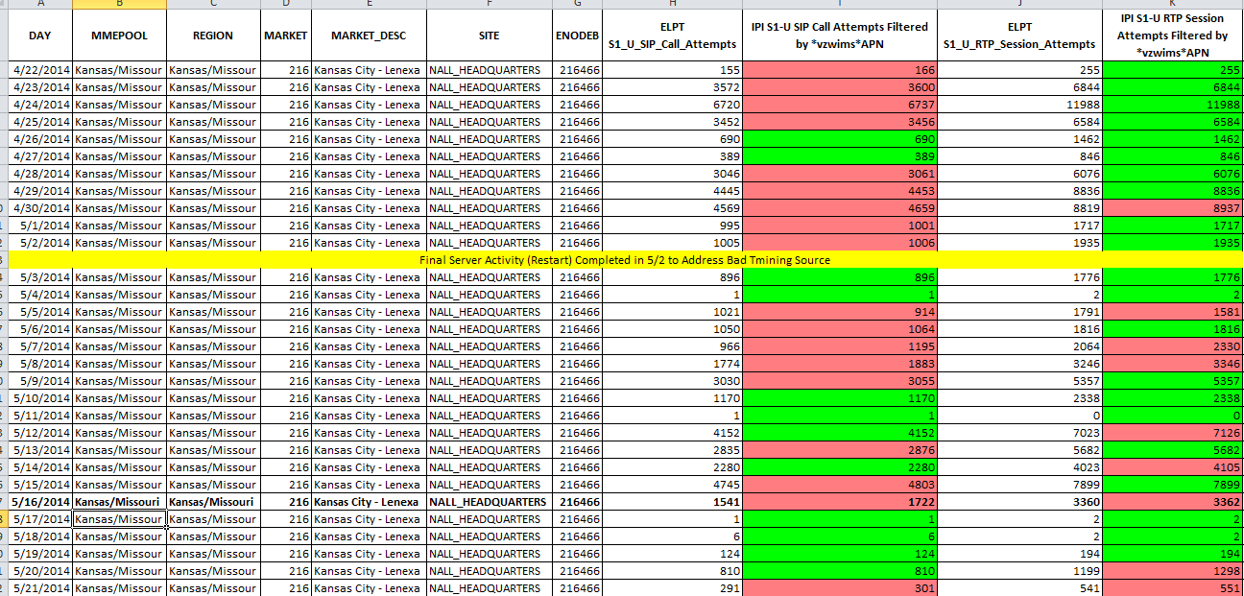

Hourly Comparison for May 16th – ELPT and IrisView

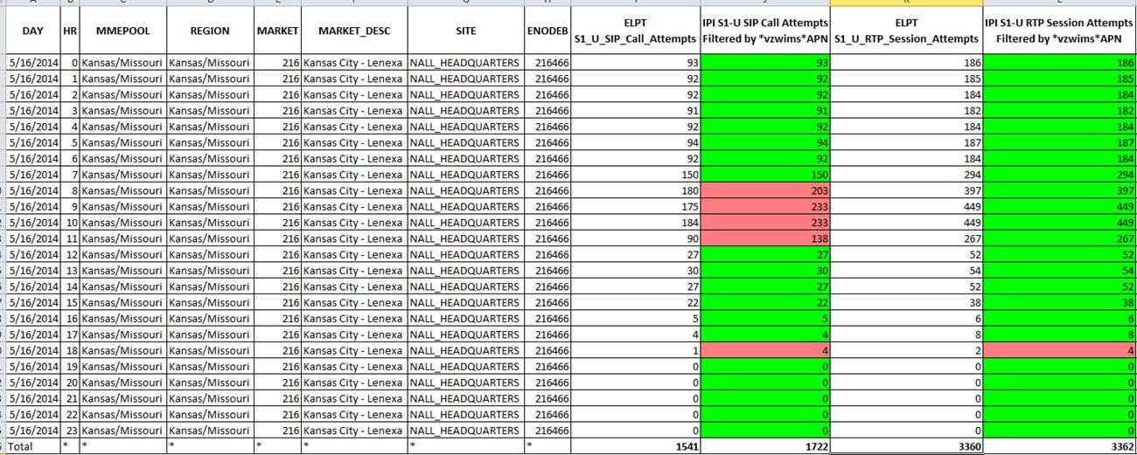

Daily SIP KPIs for eNB 216466_NALL_HEADQUARTERS

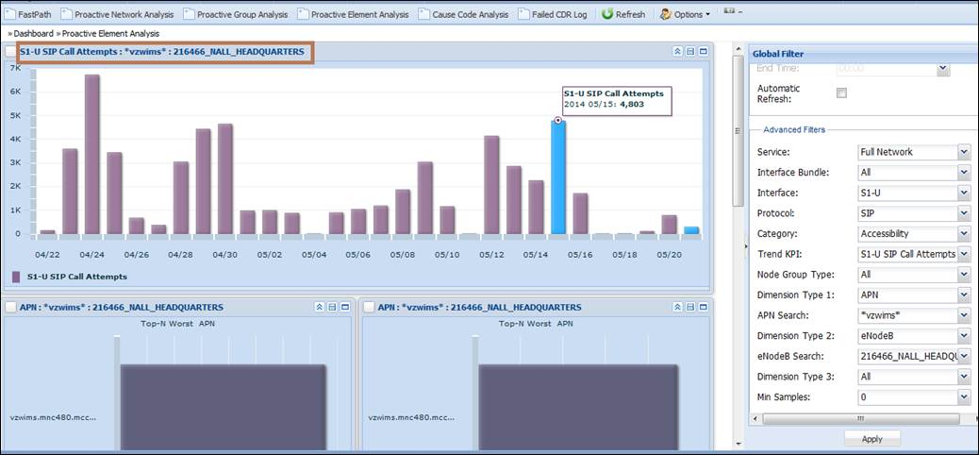

Hourly SIP KPIs for eNB 216466_NALL_HEADQUARTERS

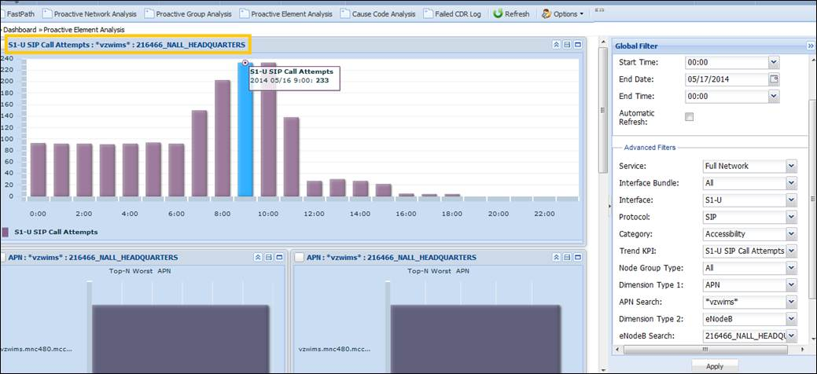

Hourly RTP KPIs for eNB 216466_NALL_HEADQUARTERS

